**RoomCast Configuration and Enactment Guide**

RoomCast is a web-based configuration and distribution system for digital learning resources. It is designed for instructional units involving multiple stakeholders with distinctive resource needs that vary across multiple activity contexts.

**Configuring your unit using RoomCast**

*Step 1: Select/configure digital resources*

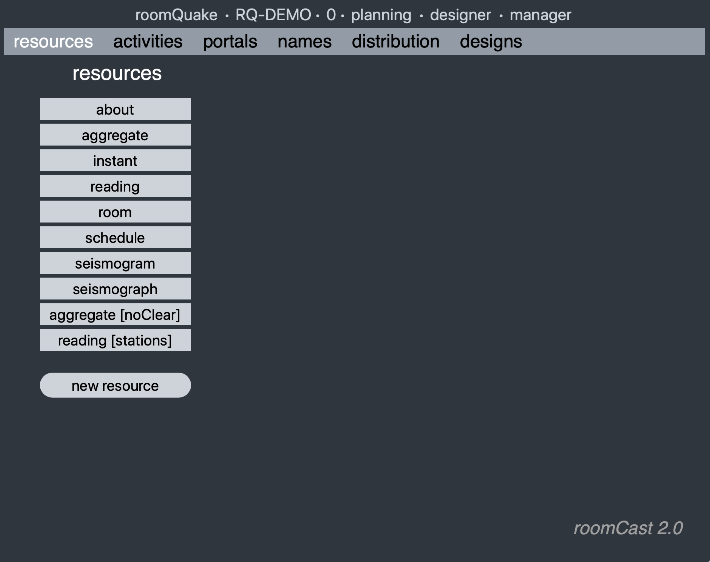

The *resources* tab is used to manage the set of digital resources (web pages) that will be available to other users of the system. If this is a *specialized* gateway, it comes pre-populated with a set of 'starter' resources specifically designed to support instructional units focused around a particular domain. (Here, we are using a RoomQuake gateway, so it contains a set of resources centering on earthquakes and seismology.) If this were a generic gateway, no default resources would be provided.

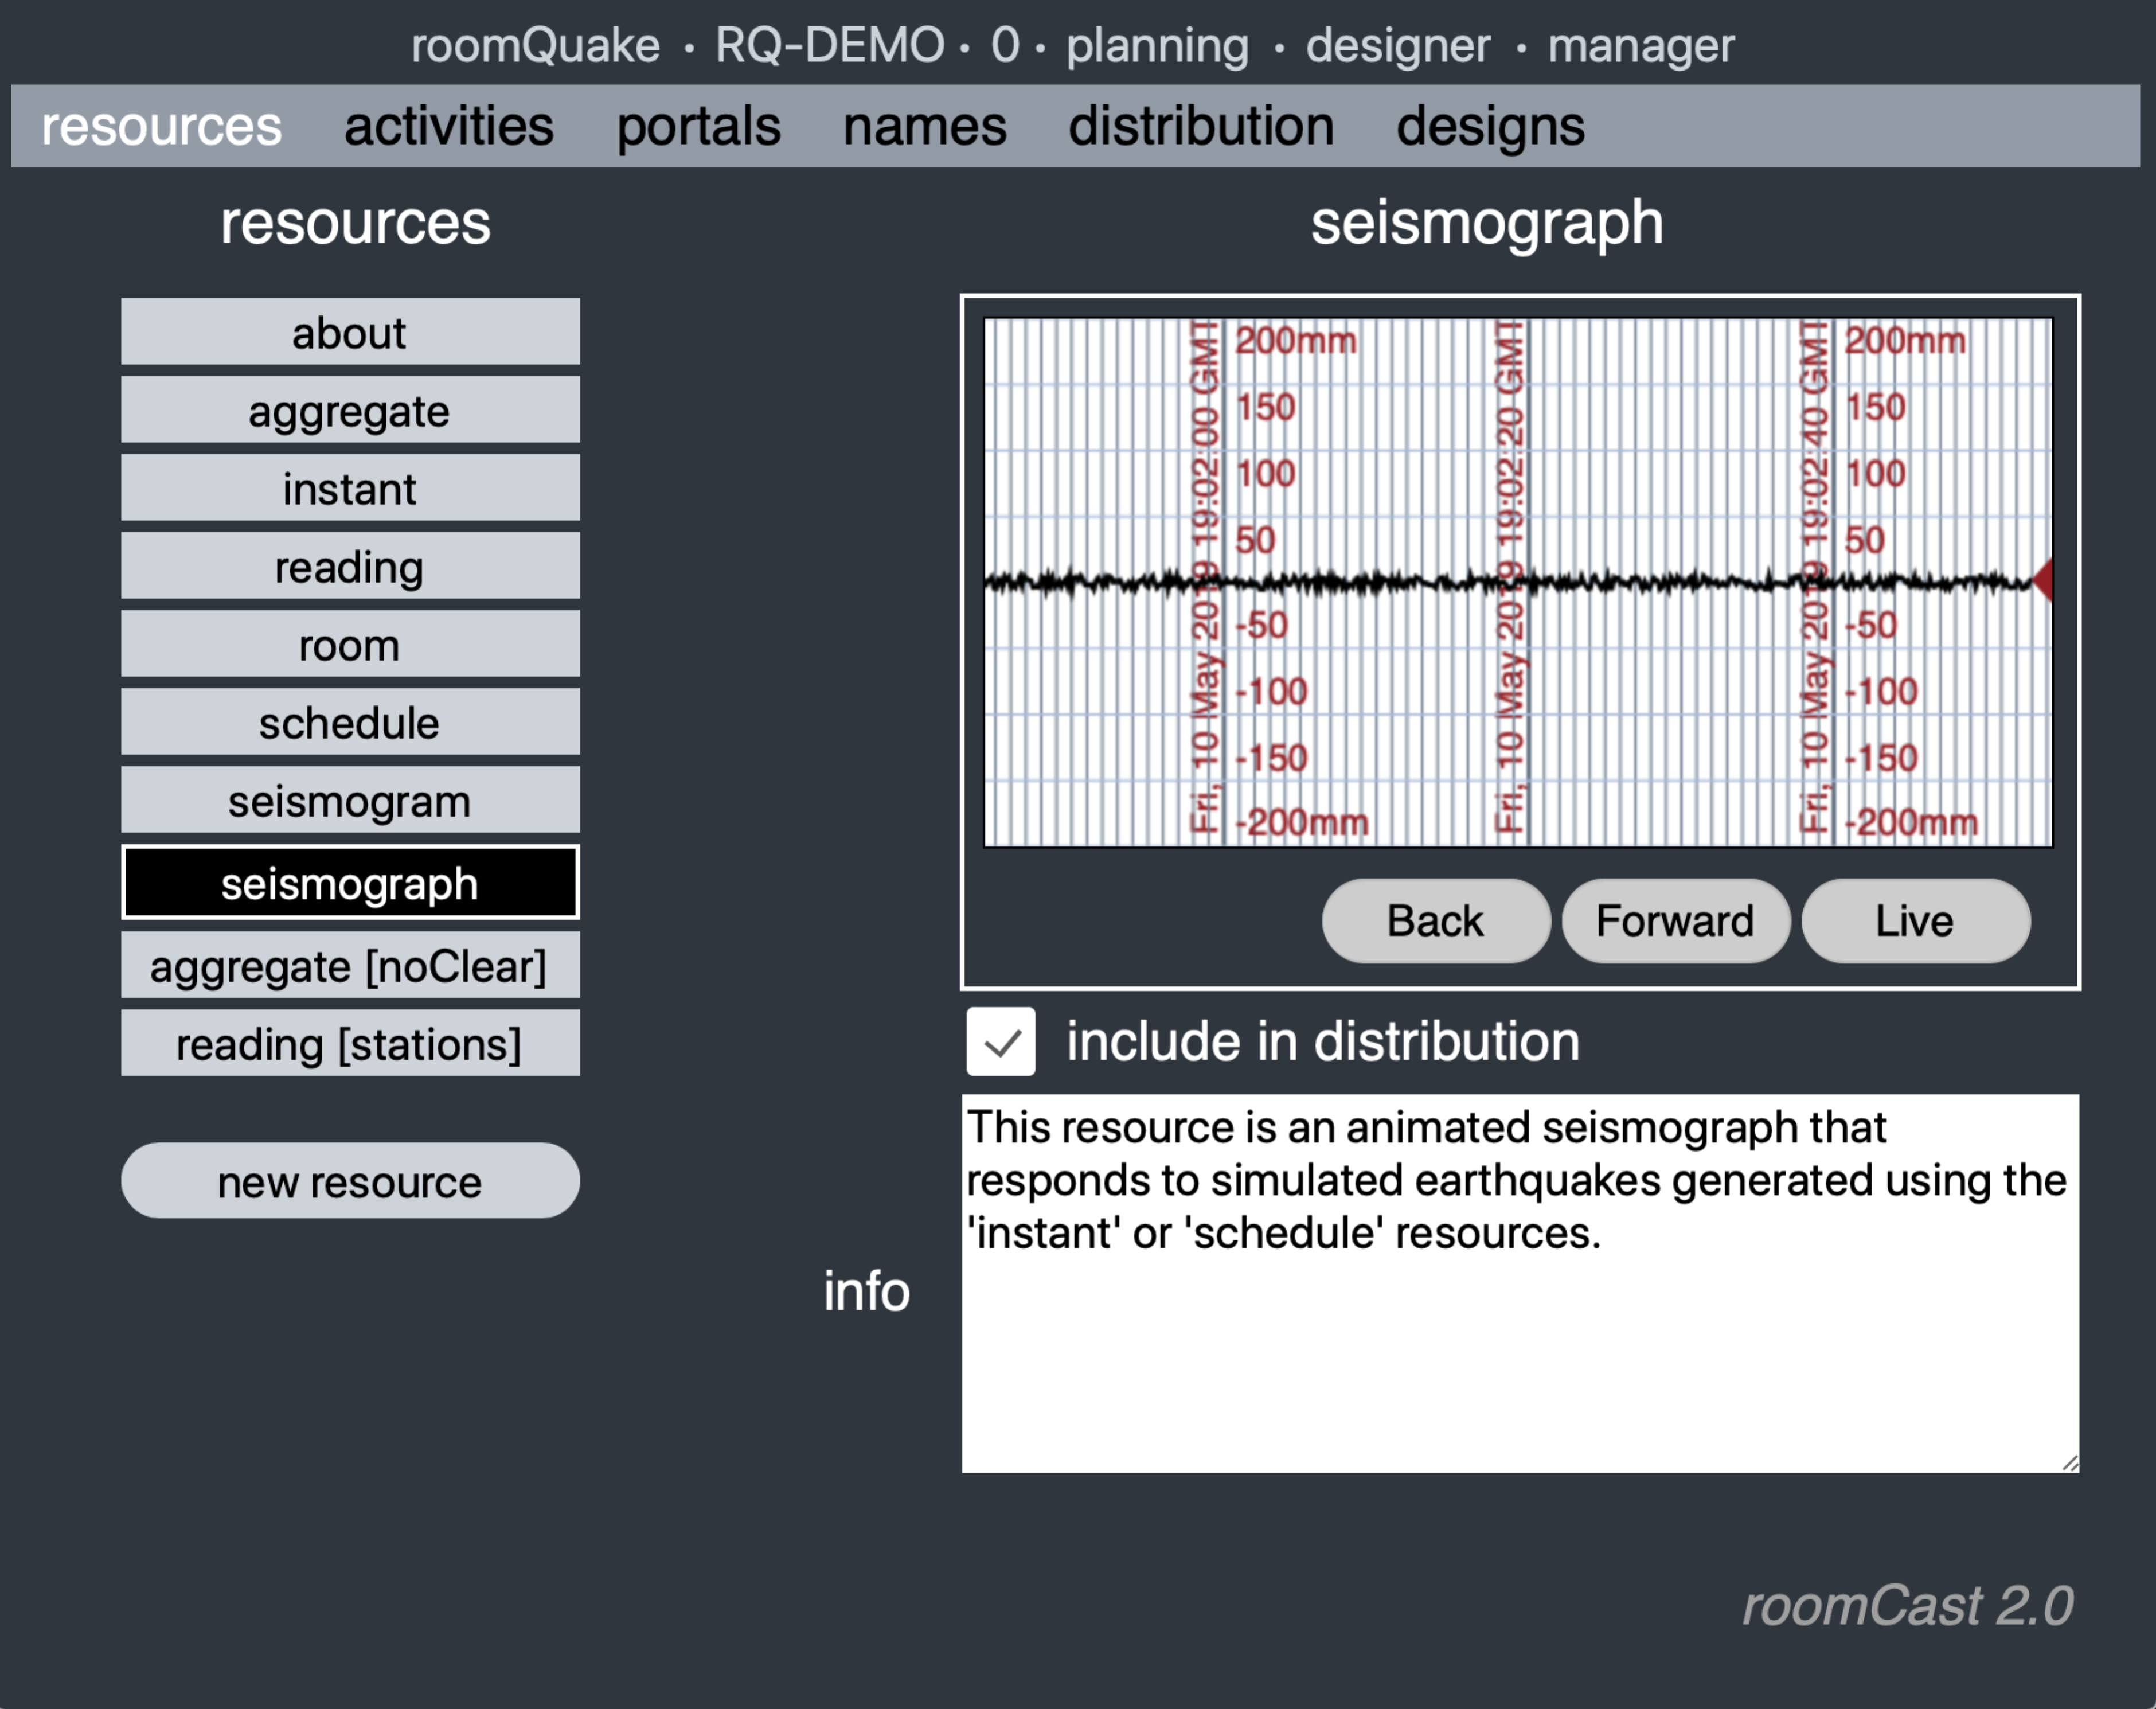

Clicking on an item in the resources list will present you with a thumbnail image of the resource and a description of its functionality. Depending on the unit that you are designing, you may not want to use all of the resources that are provided within the application gateway. If you are planning to use a particular resource, you should click the textbox 'include in distribution.'

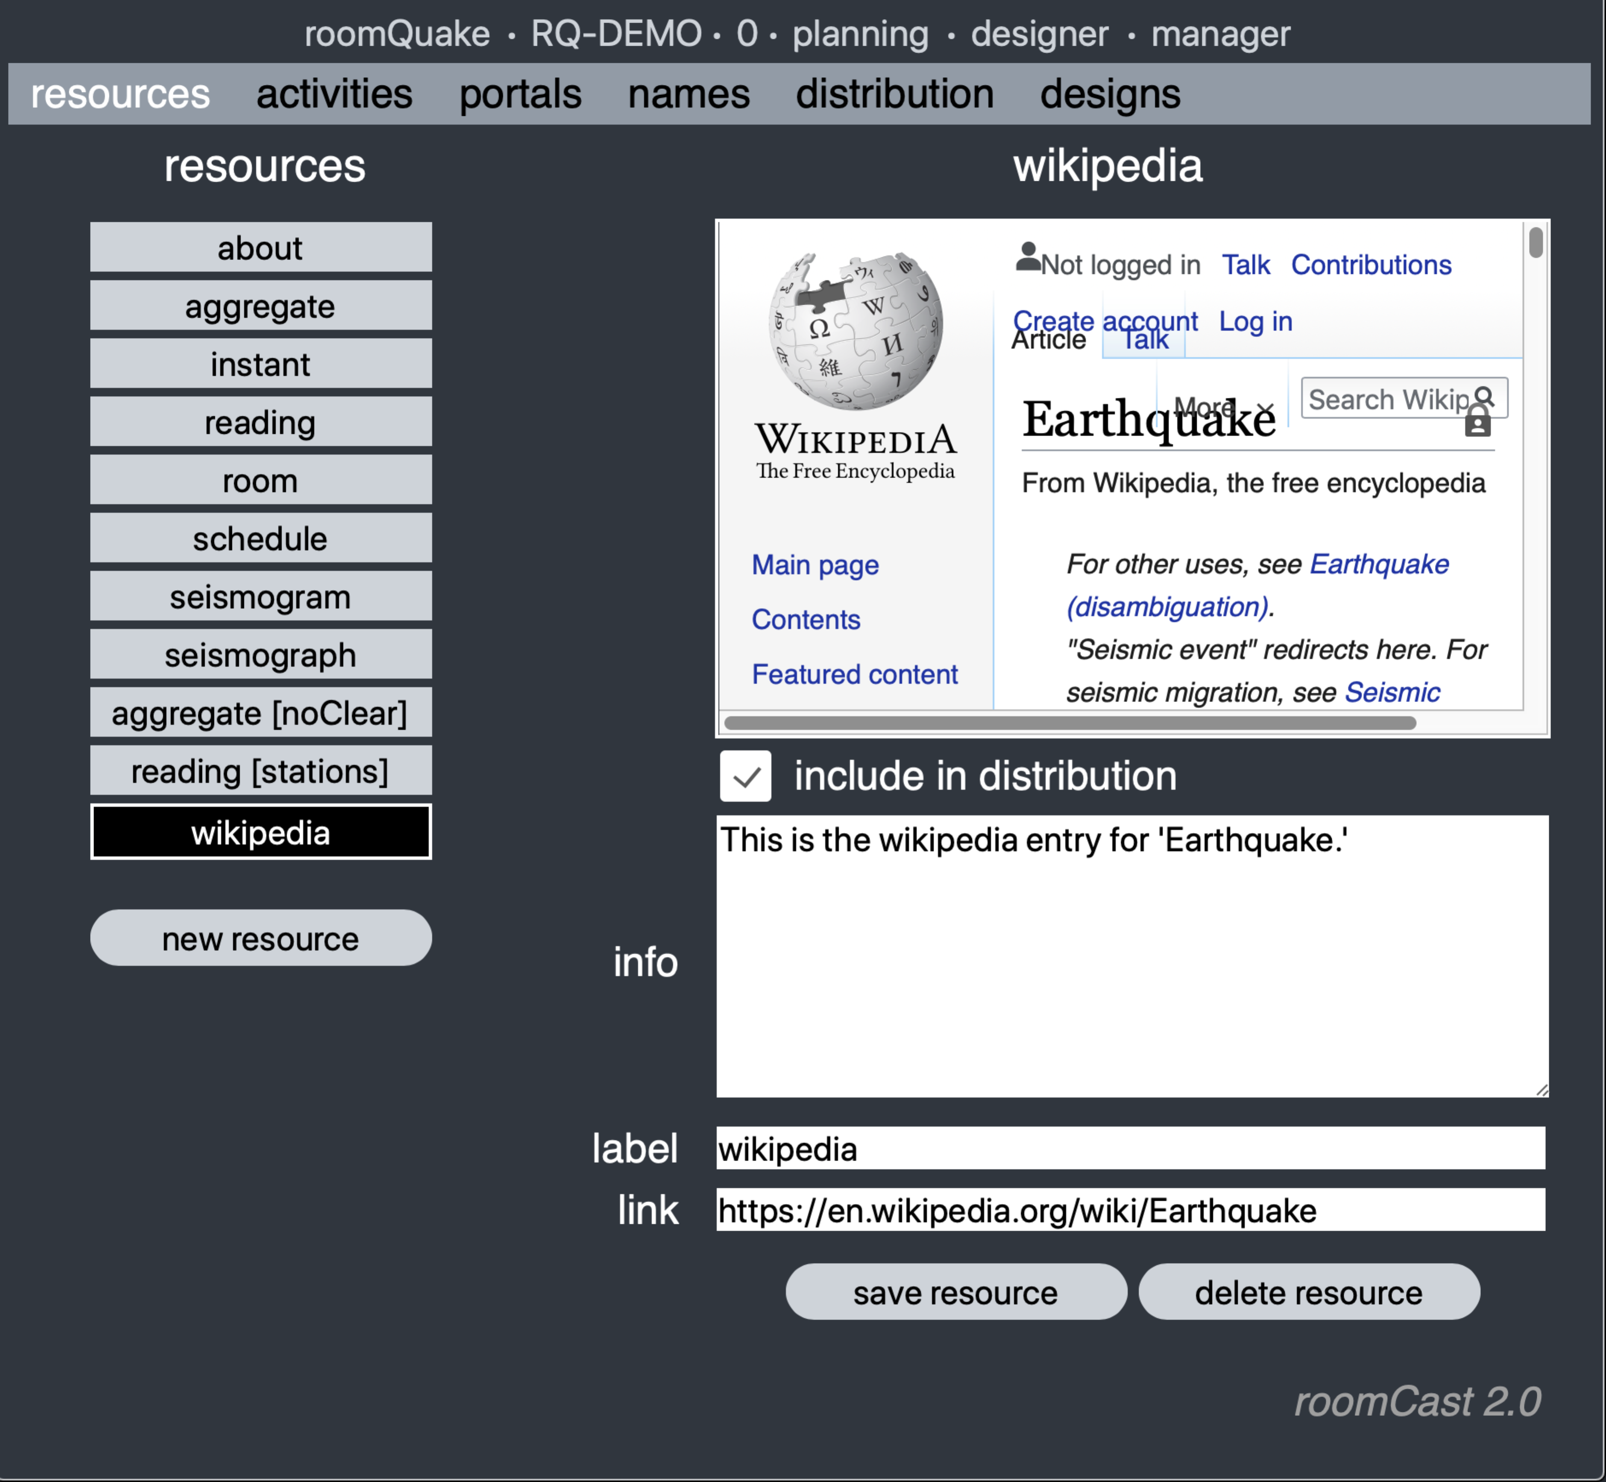

Clicking on the 'new resource' button allows you to define a new web resource to be added to the set. Here we have supplemented the built-in RoomQuake resources with the Wikipedia page for earthquakes by giving the resource a label, the link to the resource, and a description. Not every web page can be embedded within a RoomCast configuration; some require special action to make them 'public' (e.g., Google docs), and others are prohibited due to intellectual property issues (not everyone wants you to embed their work inside your application).

*Step 2: Specify activities*

Once your resources have been configured, it is time to specify the activities that will comprise your curriculum unit.The *activities* tab lists the set of activities for your unit. By default, all units include a "planning" activity; all other activities need to be added by the designer.

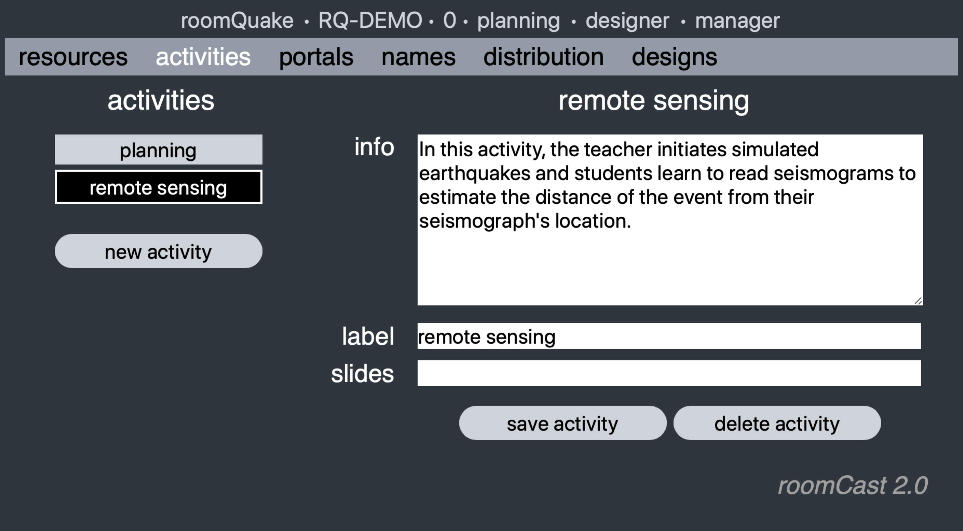

To add an activity, click on the *new activity* button, and give the activity a *label* and a *description*. (Teacher may also add a URL linking to presentation *slides* associated with this activity. To add Google slides, publish to web, then copy the URL provided into the slides field.) You may add as many activities as you like. Activities do not have to be enacted in any particular order during the unit.

*Step 3: Specify portals*

Once you have specified the activities comprising your unit, the next task is to specify the *portals* that various stakeholders will be using during the unit. You do not need to define a separate portal for each individual; in Step 5 you'll see how multiple users can each get their own "copy" of the portal.

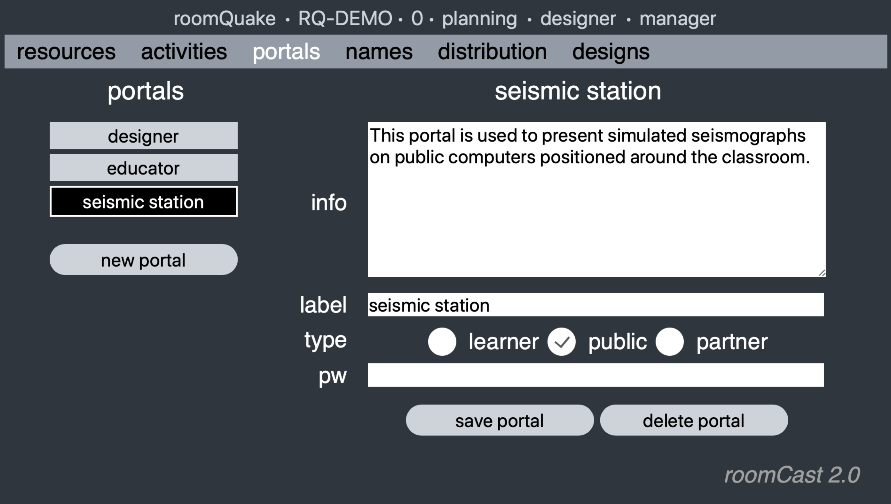

Clicking on the *portals* tab brings up the list of portals currently defined for your unit. By default, there are only two special portals: one for the designer and one for the educator. In this example, the designer has added a new portal, 'seismic station,' and provided information on how it will be used.

There are three types of portals. *Learner* portals are intended for use by individuals or groups. (Note that as activities change, students may switch to a different portal. For example, a designer might specify both "student" and "group" portals, or use different portals to develop "jigsaw" cooperative learning designs.) *Public* portals are intended for use on large displays or computer 'kiosks' situated around the classroom, accessible to all participants. (These might be used, for example, to create specialized activity stations or information resources, to present shared simulations for whole-class use.) *Partner* portals are intended for use by other stakeholders. These might include domain expert partners, school administrators, software developers, researchers, student teachers, or any other specialized role that you would like to include. In this case, because the seismic stations are intended for continuous public display, we have designated them as public portals.

With the exception of the designer and educator, by default, all portals can be chosen through the gateway URL. You may, however, specify that a password be required to use a particular portal (just as you provide a password when you chose the designer or educator portals).

*Step 4: Specify distribution plan*

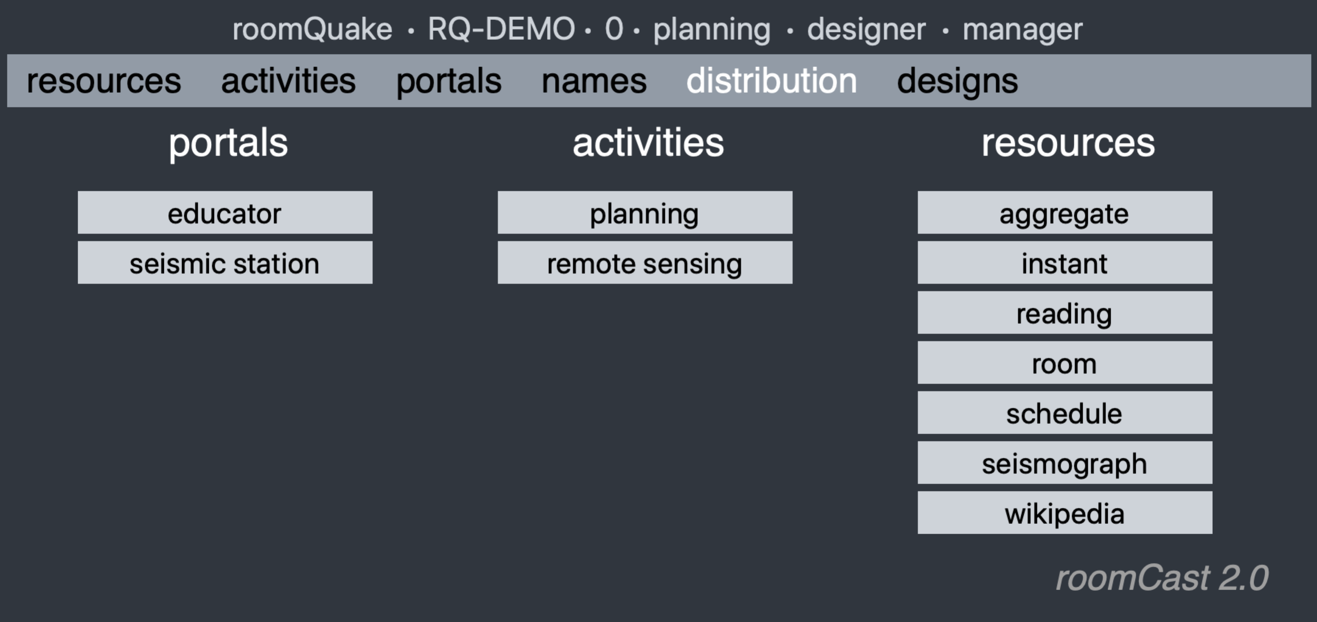The *distribution* tab presents a three-column "distribution grid" summarizing the portals, activities, and resources that you have specified for use in your unit. (The resources list presents only those you have specified to "include in distribution" in Step 1. If you need to include a new resource, you can change that at any time and this page will automatically update the list accordingly.)

The distribution grid specifies the resources that will be made available to each kind of portal during each of the unit activities. To see a resource list, select a portal and an activity; the highlighted items in the resource list are the ones that will be made available to that portal during that activity. During enactment, the educator has the ability to switch to a different activity at any time; when activities change, all active users will immediately receive the new set of resources specified in the distribution grid.

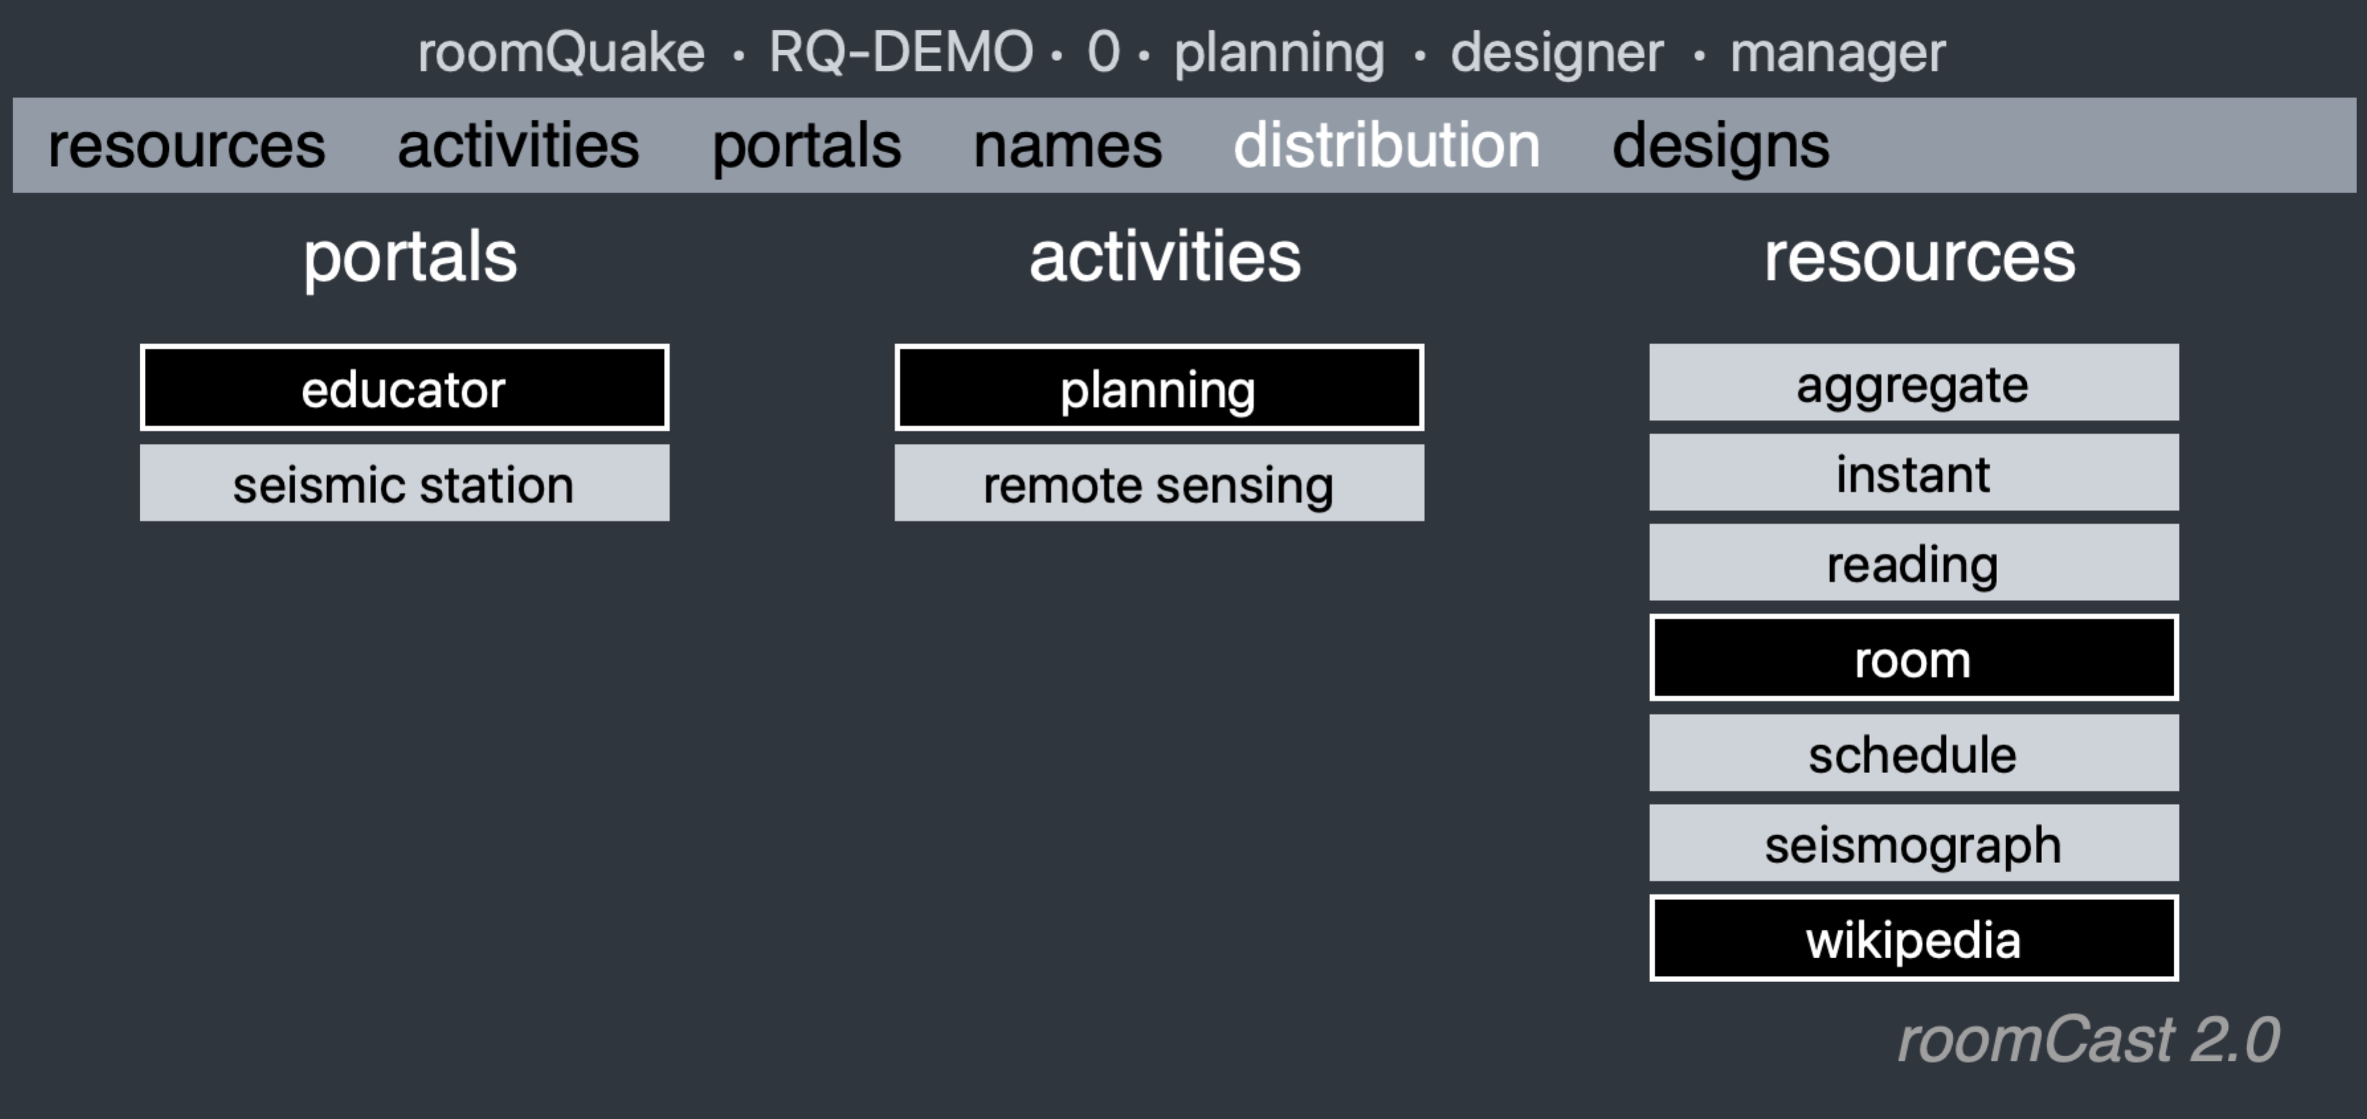

In this example, we see that the educator, during the planning activity, will be provided with two resources: a *room* configuration resource (to help them in specifying the locations of the seismic stations in the classroom), and the *Wikipedia* earthquakes page to provide them a reference document for the unit. To add a resource, simply click on its name; it will immediately become available to anyone logged in through that portal during the designated activity.

Providing a full distribution plan requires that you work your way through all combinations of portals and activities. Some designers like to select a portal, and then proceed to specify the resources that portal will need during each activity. In other cases, designers may "lock down" the activity, and then systematically select the resources needed for each portal. You can drag the three columns left and right to rearrange them to fit your style.

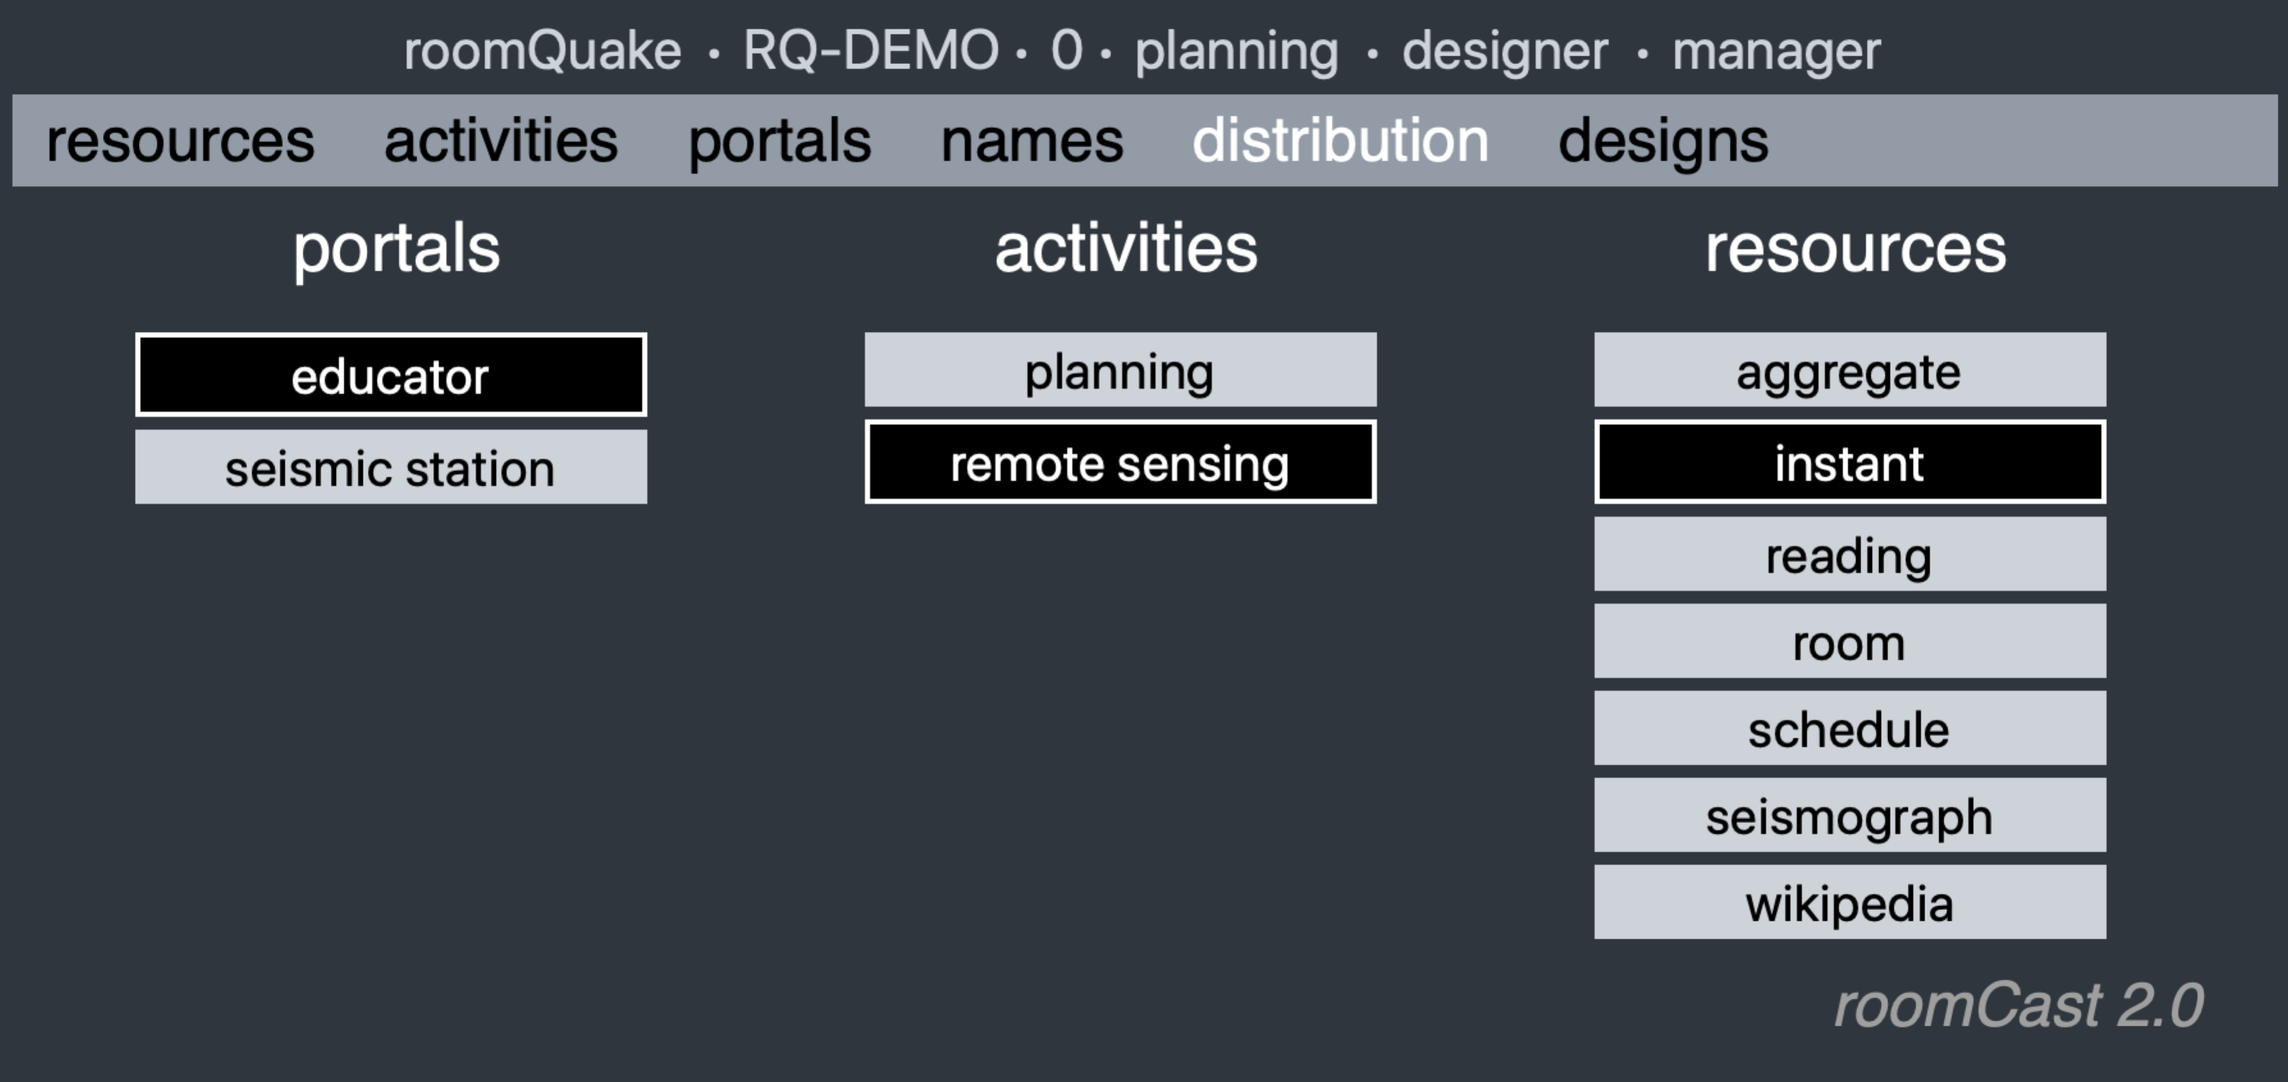

In this example, we leave the 'educator' portal selected, and choose the "remote sensing" activity. We specify that during the 'remote sensing' activity, the teacher will be provided with a resource ('instant') that allows them to generate simulated "instant" earthquakes in the classroom.

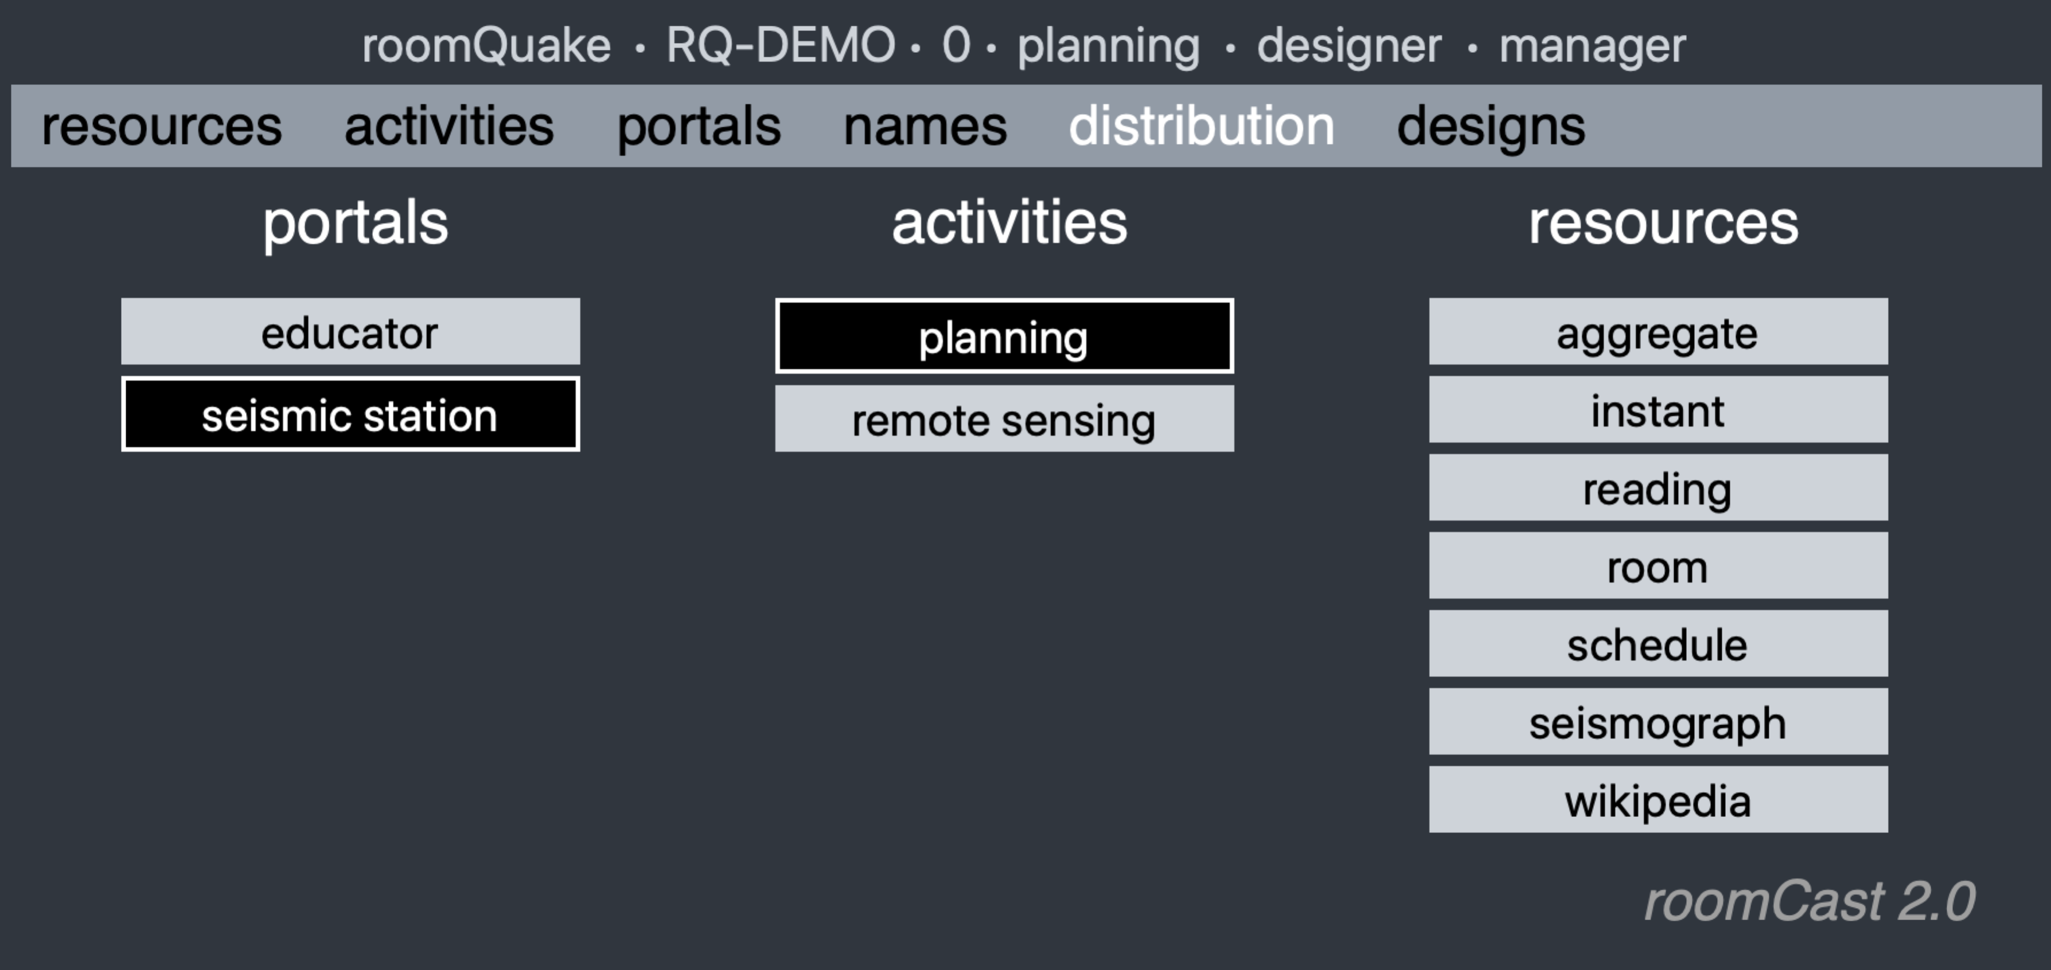

In this distribution plan, seismic stations do not require any resources during the planning activity. Opening a seismic station portal during planning would produce a page with no available resources.

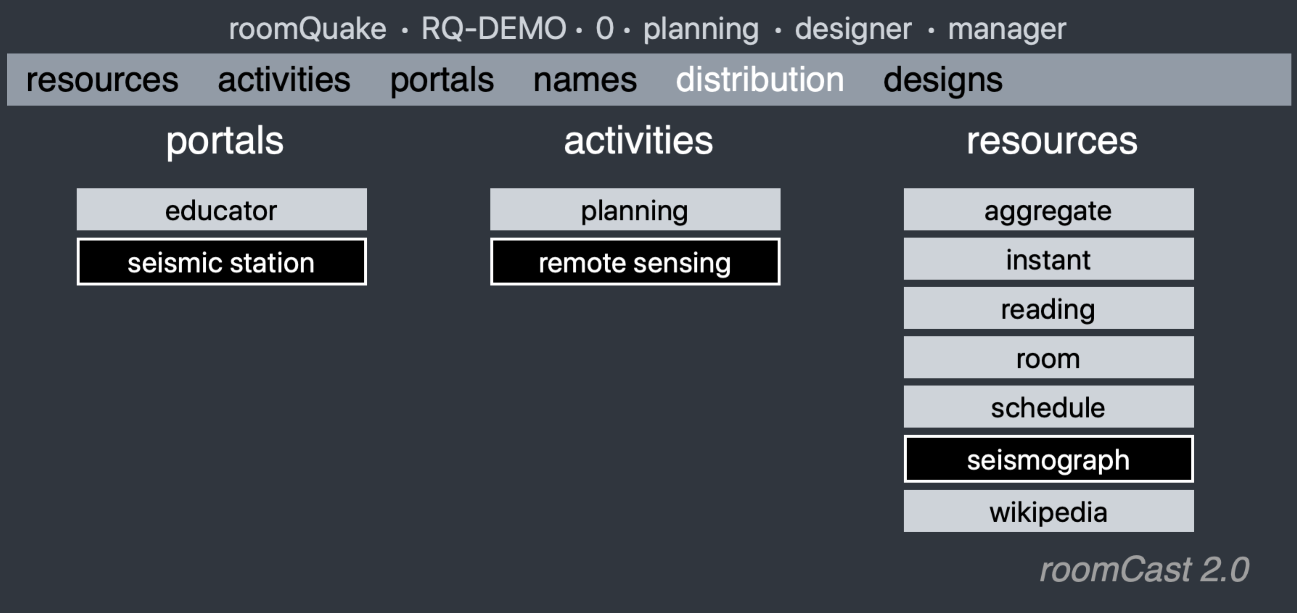

But during the 'remote sensing' activity, seismic stations set of resources will include the simulated 'seismograph' resource that we saw earlier when we introduced our resources. When the teacher generates "instant" earthquakes, each seismograph will respond with a distinctive waveform reflecting its distance from epicenter of the simulated earthquake.

*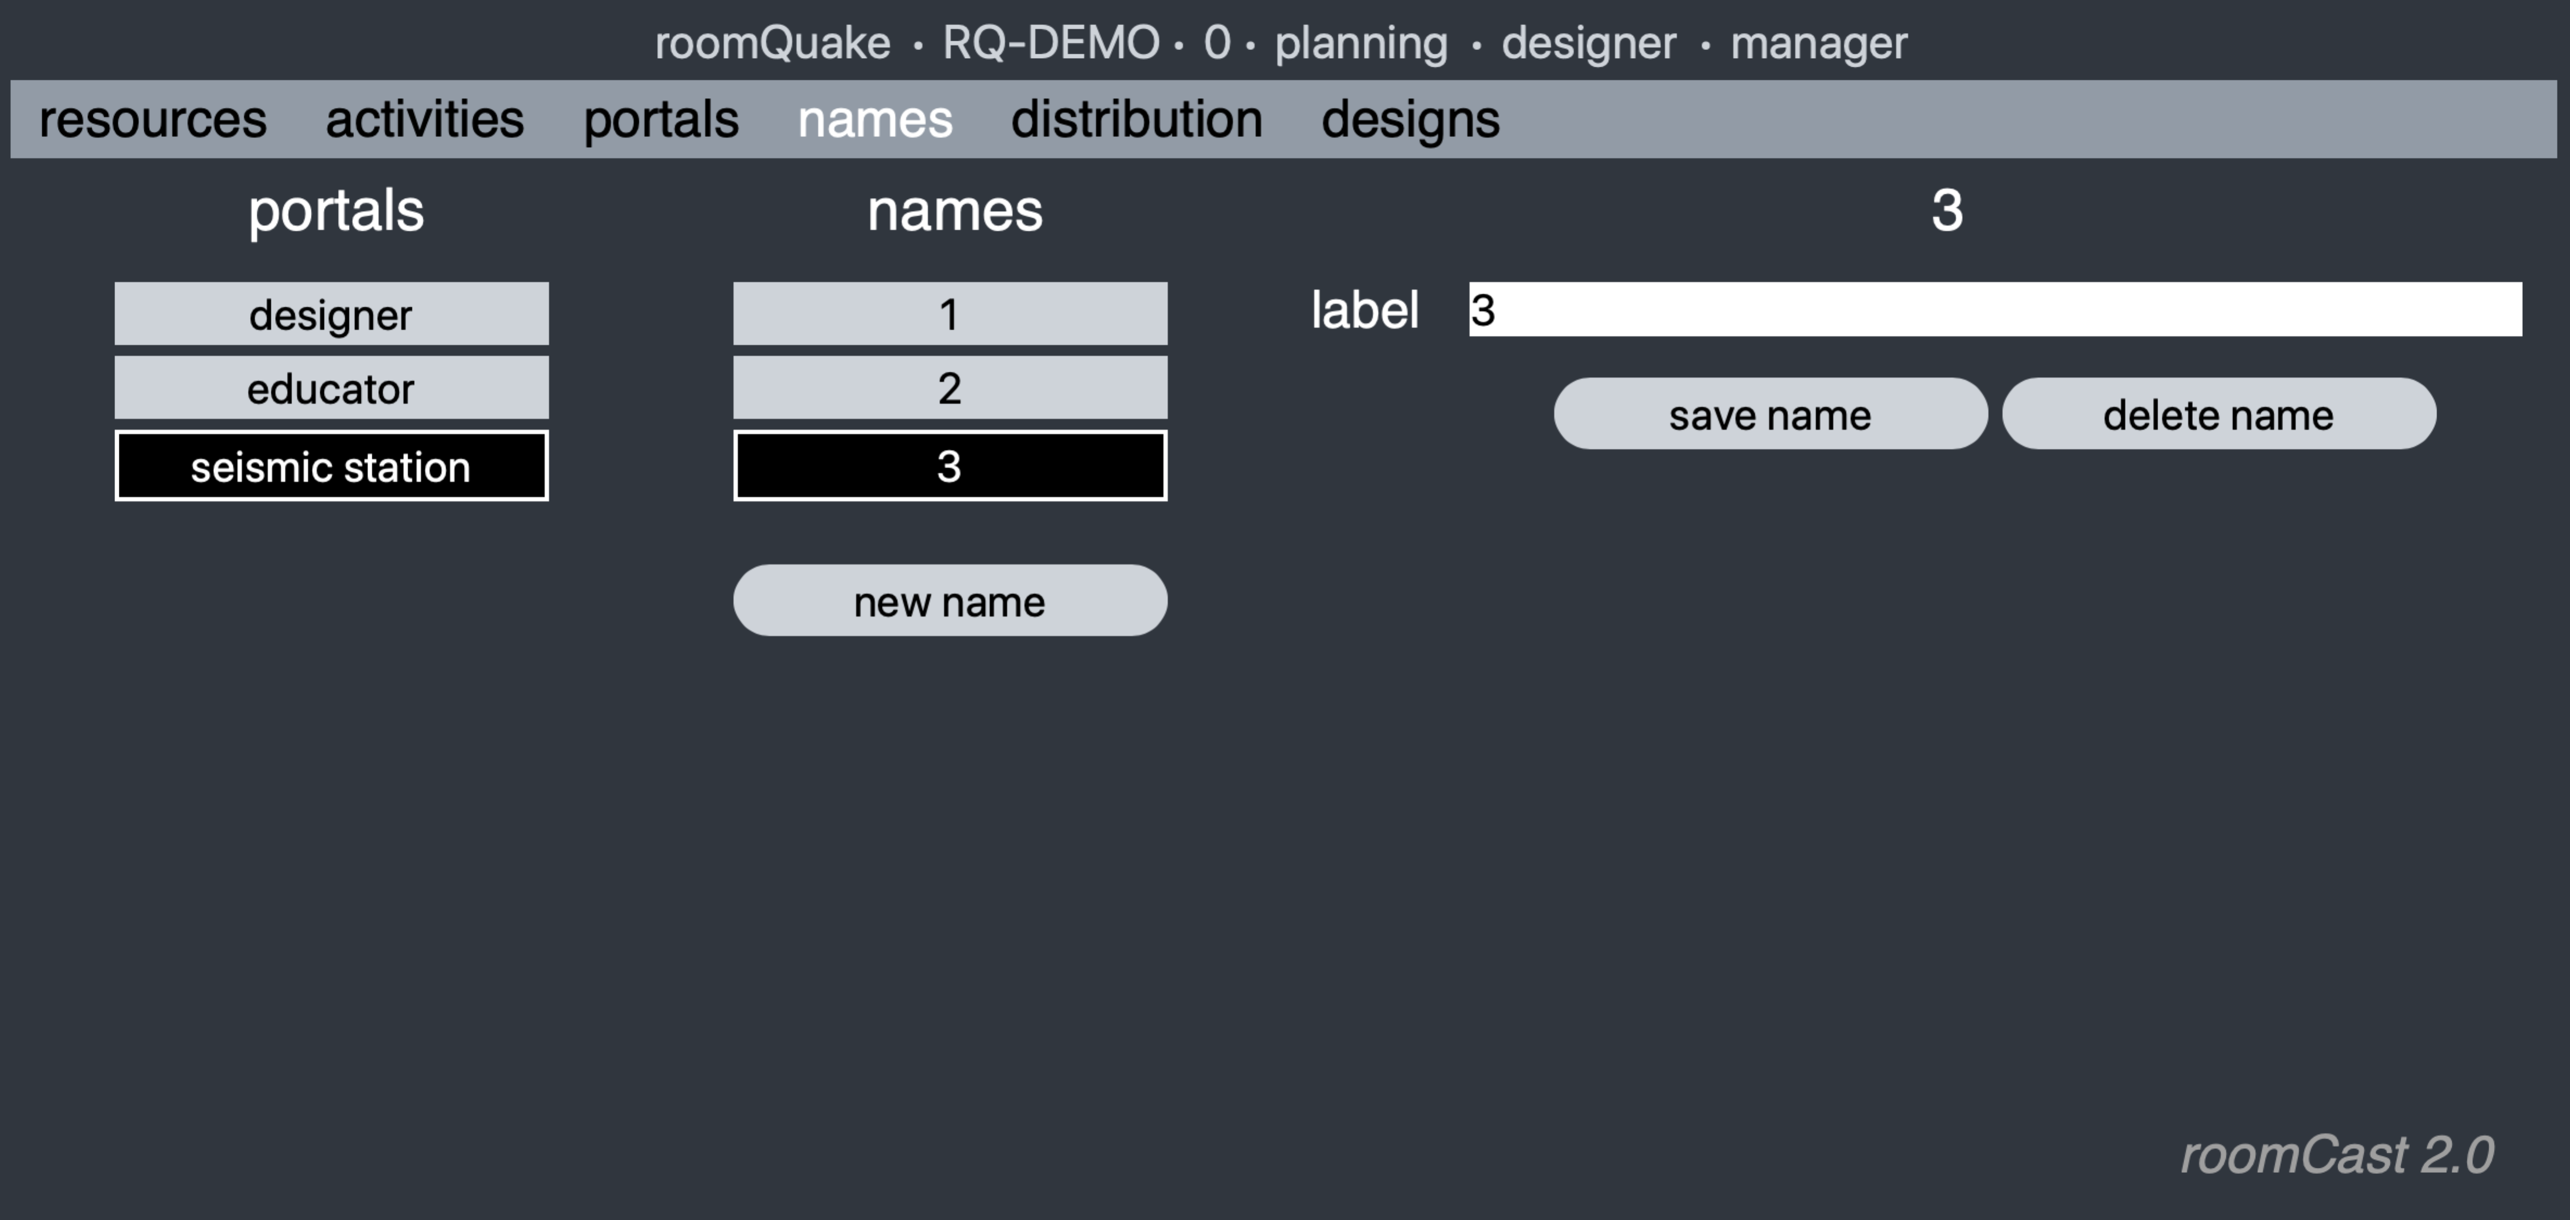Step 5: Specify names*

As mentioned in Step 3, portals represent a kind of 'template' for individual users or public devices. Associated with each type of portal is a list of *names* distinguishing those individuals. In this example, we clicked on the *names* tab, selected the 'seismic station' portal, and defined three individual instances, named 1, 2, and 3. While all three instances will have the same basic functionality (digital resources), they will operate independently. (Here, for example, all 'seismic station' portals will present simulated seismographs, but they will show different waveforms based on their distance from simulated earthquakes.) Similarly, for 'learner' portals, you are able to provide individual names for students and groups (and use those names to differentiate activity on each instance of a portal). Student can then log in by name. In the present version of RoomCast, no *individual* passwords are used; however, all individuals using a portal may need to provide the password ("classword") for that portal if one was specified (see Step 3).

**Enacting your unit using RoomCast**

You are now ready to enact your unit. You have finished your job as designer, so it is time to select one of the portals that you need to use during class.

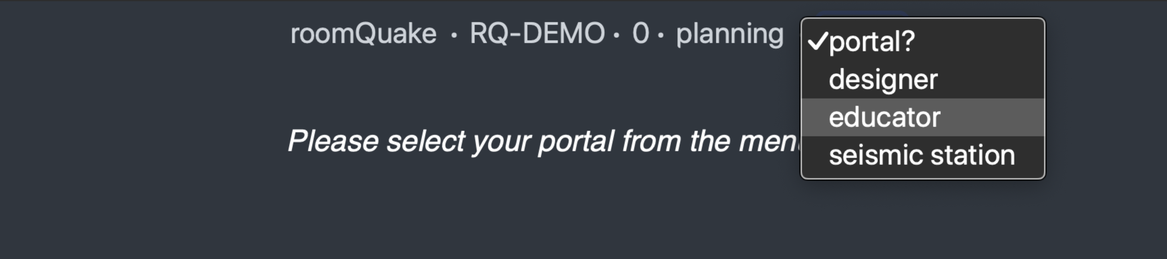

All users of the system enter through the same *gateway URL* that was provided for your class; different classes will have different gateways. Upon entering the URL, they will be shown the page above. The line of words at the top of the page is called the *status bar*. From left to right, it specifies the name of the unit ('roomQuake'), your institution (RQ-DEMO) and class (0), the current activity ('planning'), and the selected portal. When you first log in, RoomQuake asks you to select a portal.

In the status bar you can click on (some) items to make new selections. Here, your can click on 'designer' and change your portal to 'educator.' (Or, on another device, use the gateway URL, select the 'educator' portal instead of the 'designer' portal that we have been using.) When there is only one individual name associated with a portal, the user is automatically "logged in" under that name.

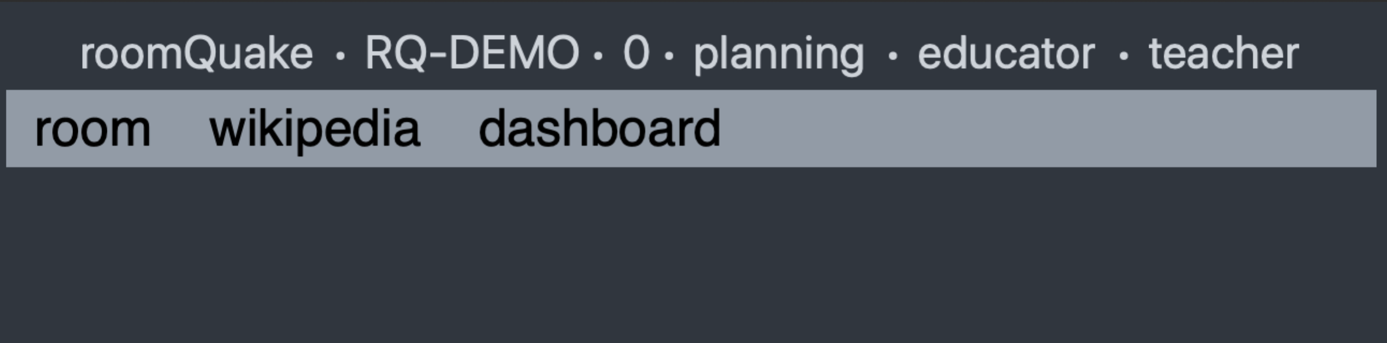

Because we are in the 'planning' activity, the *resources bar* includes the two resources that we specified for educators during planning in our distribution plan: the room configuration tool (one of the RoomQuake resources) and the Wikipedia page that we added as a resource to our unit. Clicking on a resource will make it available in the space beneath the bar.

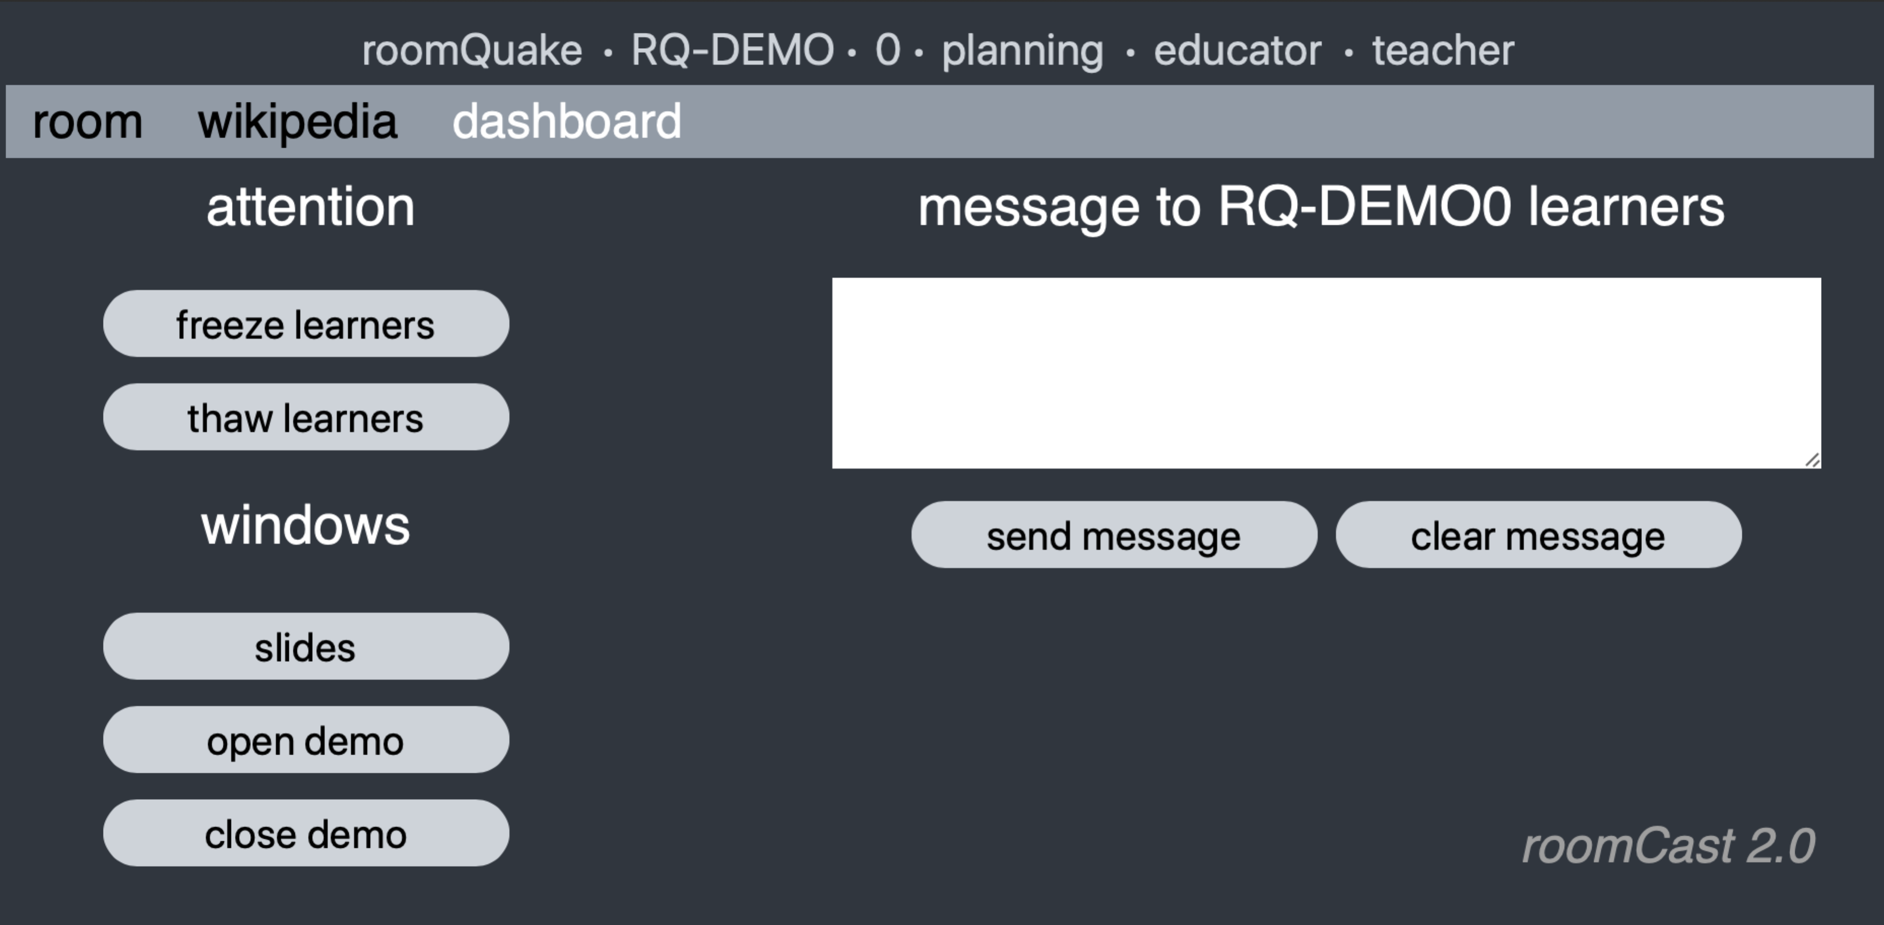

One resource, the *dashboard*, is always added as a resource for the educator, regardless of the current activity. It allows teachers to temporarily "freeze" learner devices, rendering them unresponsive when teachers need student attention, and to "thaw" them allowing normal operation to continue. Teachers can also broadcast messages to students; these will immediately appear as pop-up dialog boxes on student devices. The other buttons pop up new windows on the teacher's device, including slides associated with the current activity (see above); these are added as a separate tab in the web browser.

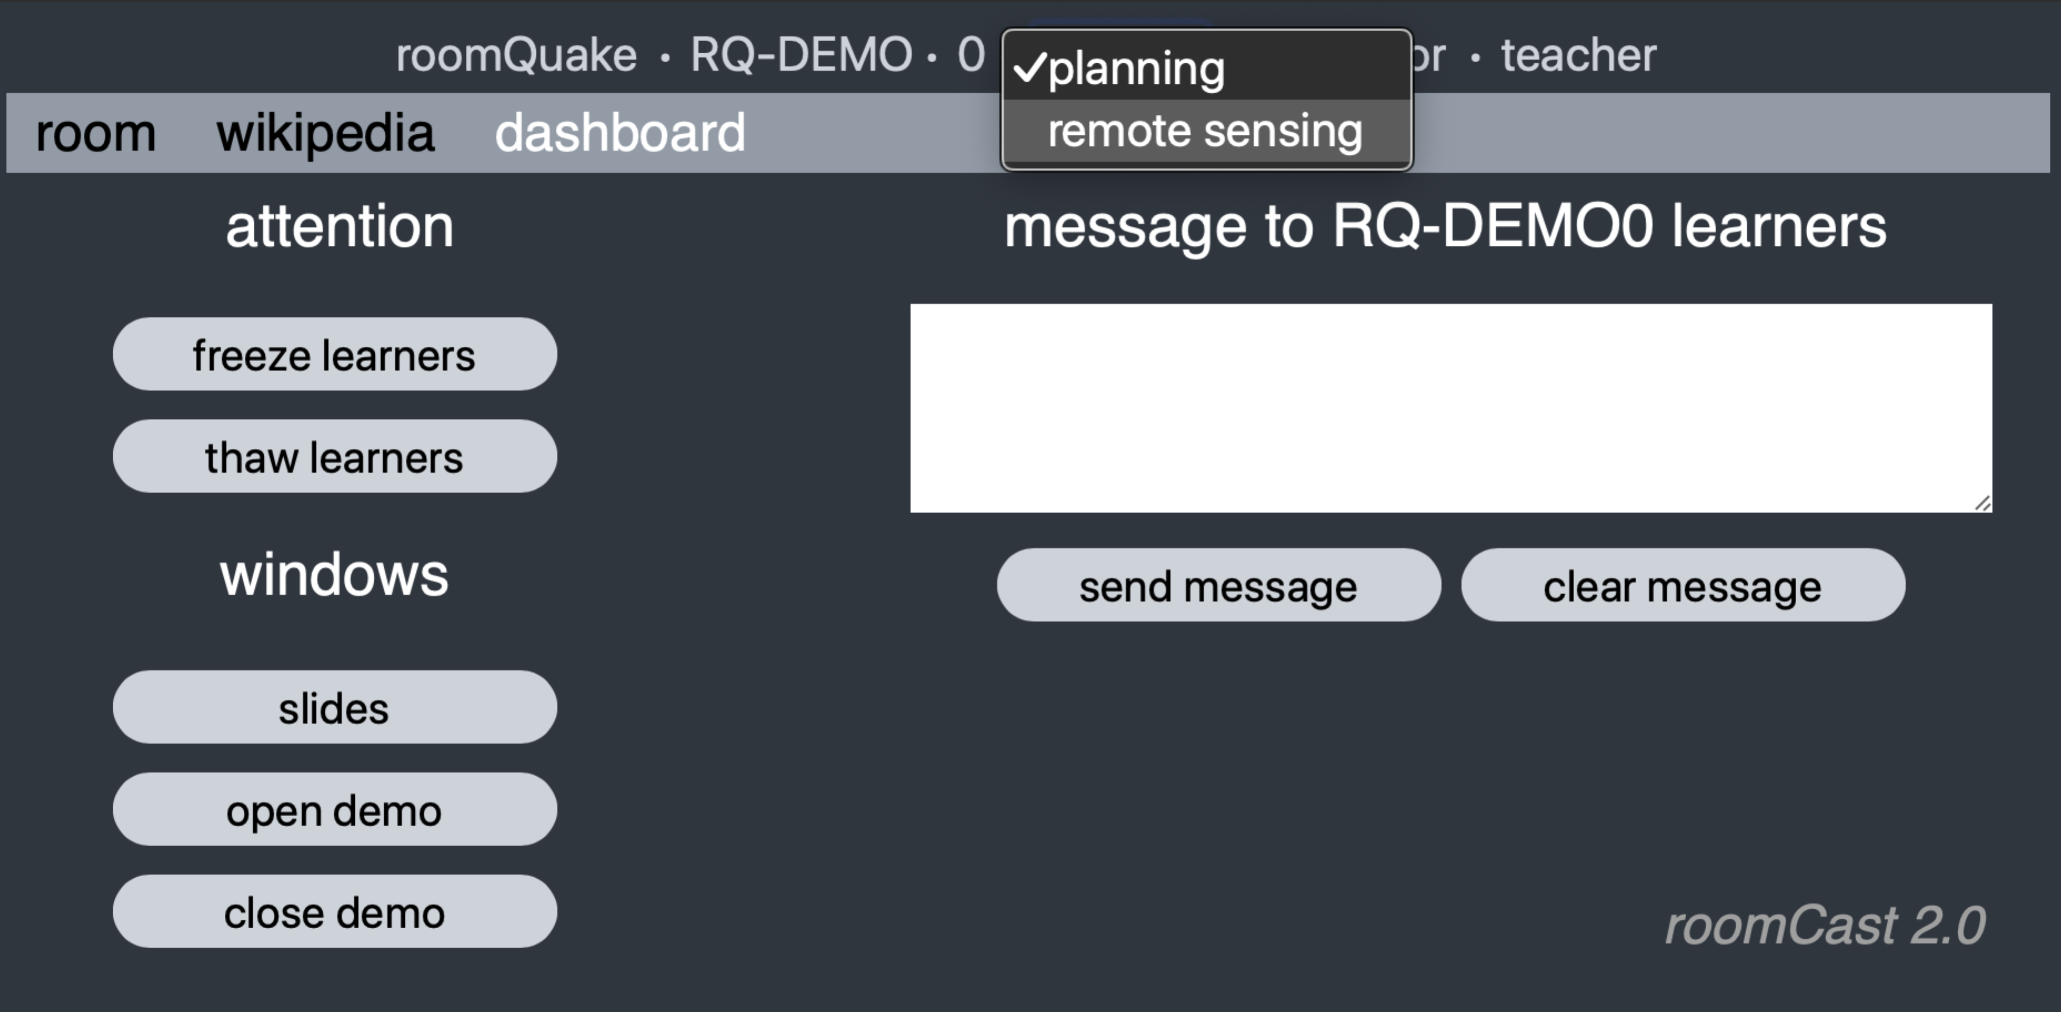

During planning, the teacher would use the 'room' configuration tool to configure the location of the seismic stations (not shown). Once configured, the teacher changes from the 'planning' activity to the 'remote sensing' activity by selecting that activity in the status bar.

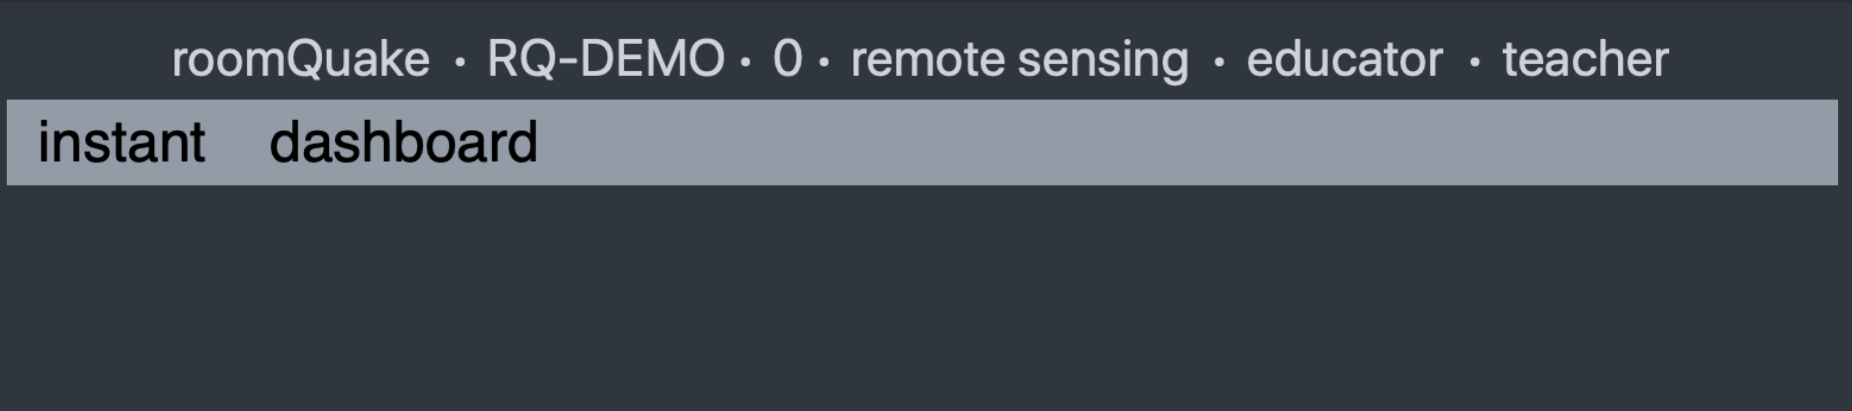

When the teacher changes the activity, all of the devices serving as portals for the unit are immediately updated to reflect the set of resources that were configured that portal/activity combination. Here, the room configuration and Wikipedia resources have been replaced by the 'instant' earthquake tool that the teacher will use to generated simulated earthquakes.

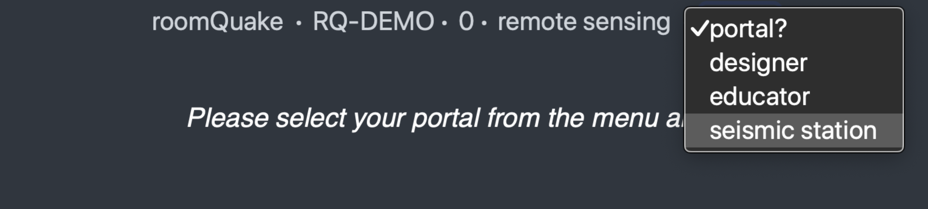

To bring the seismic stations into the picture, the teacher (or students) enter the *gateway* URL on the browsers running on each computer serving as a seismic station, and specify that they want to run a 'seismic station' portal.

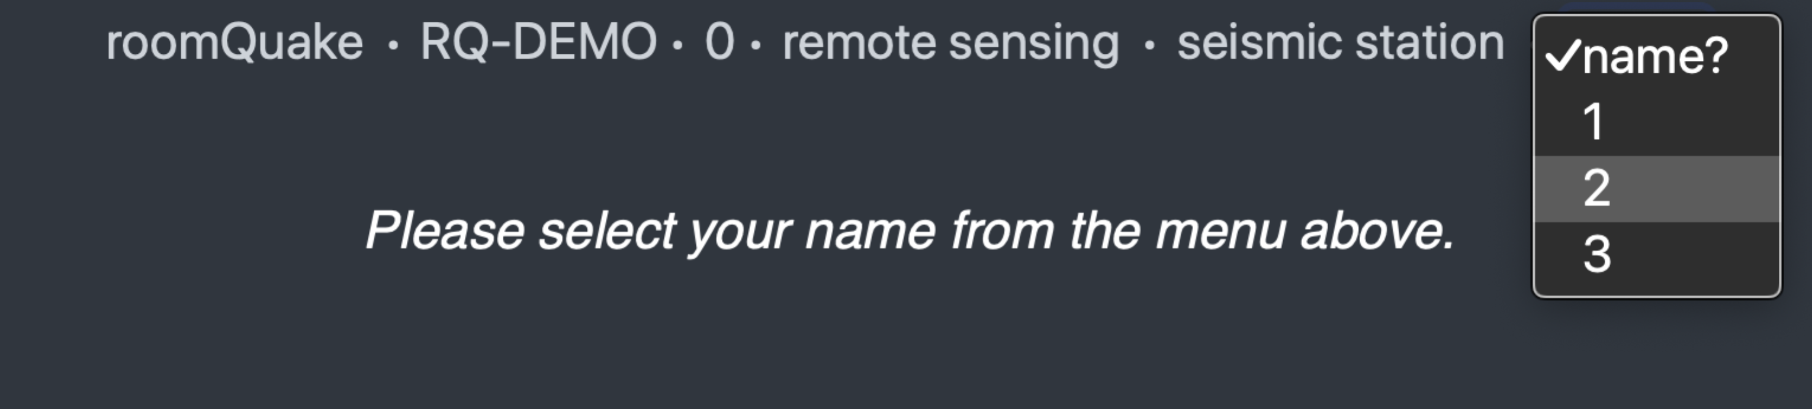

Because there is more than one seismic station, we need to specify which one this portal is intended to represent. (Again, different seismic stations will produce different waveforms depending on their location in the classroom, which the teacher specified using the room configuration resource).

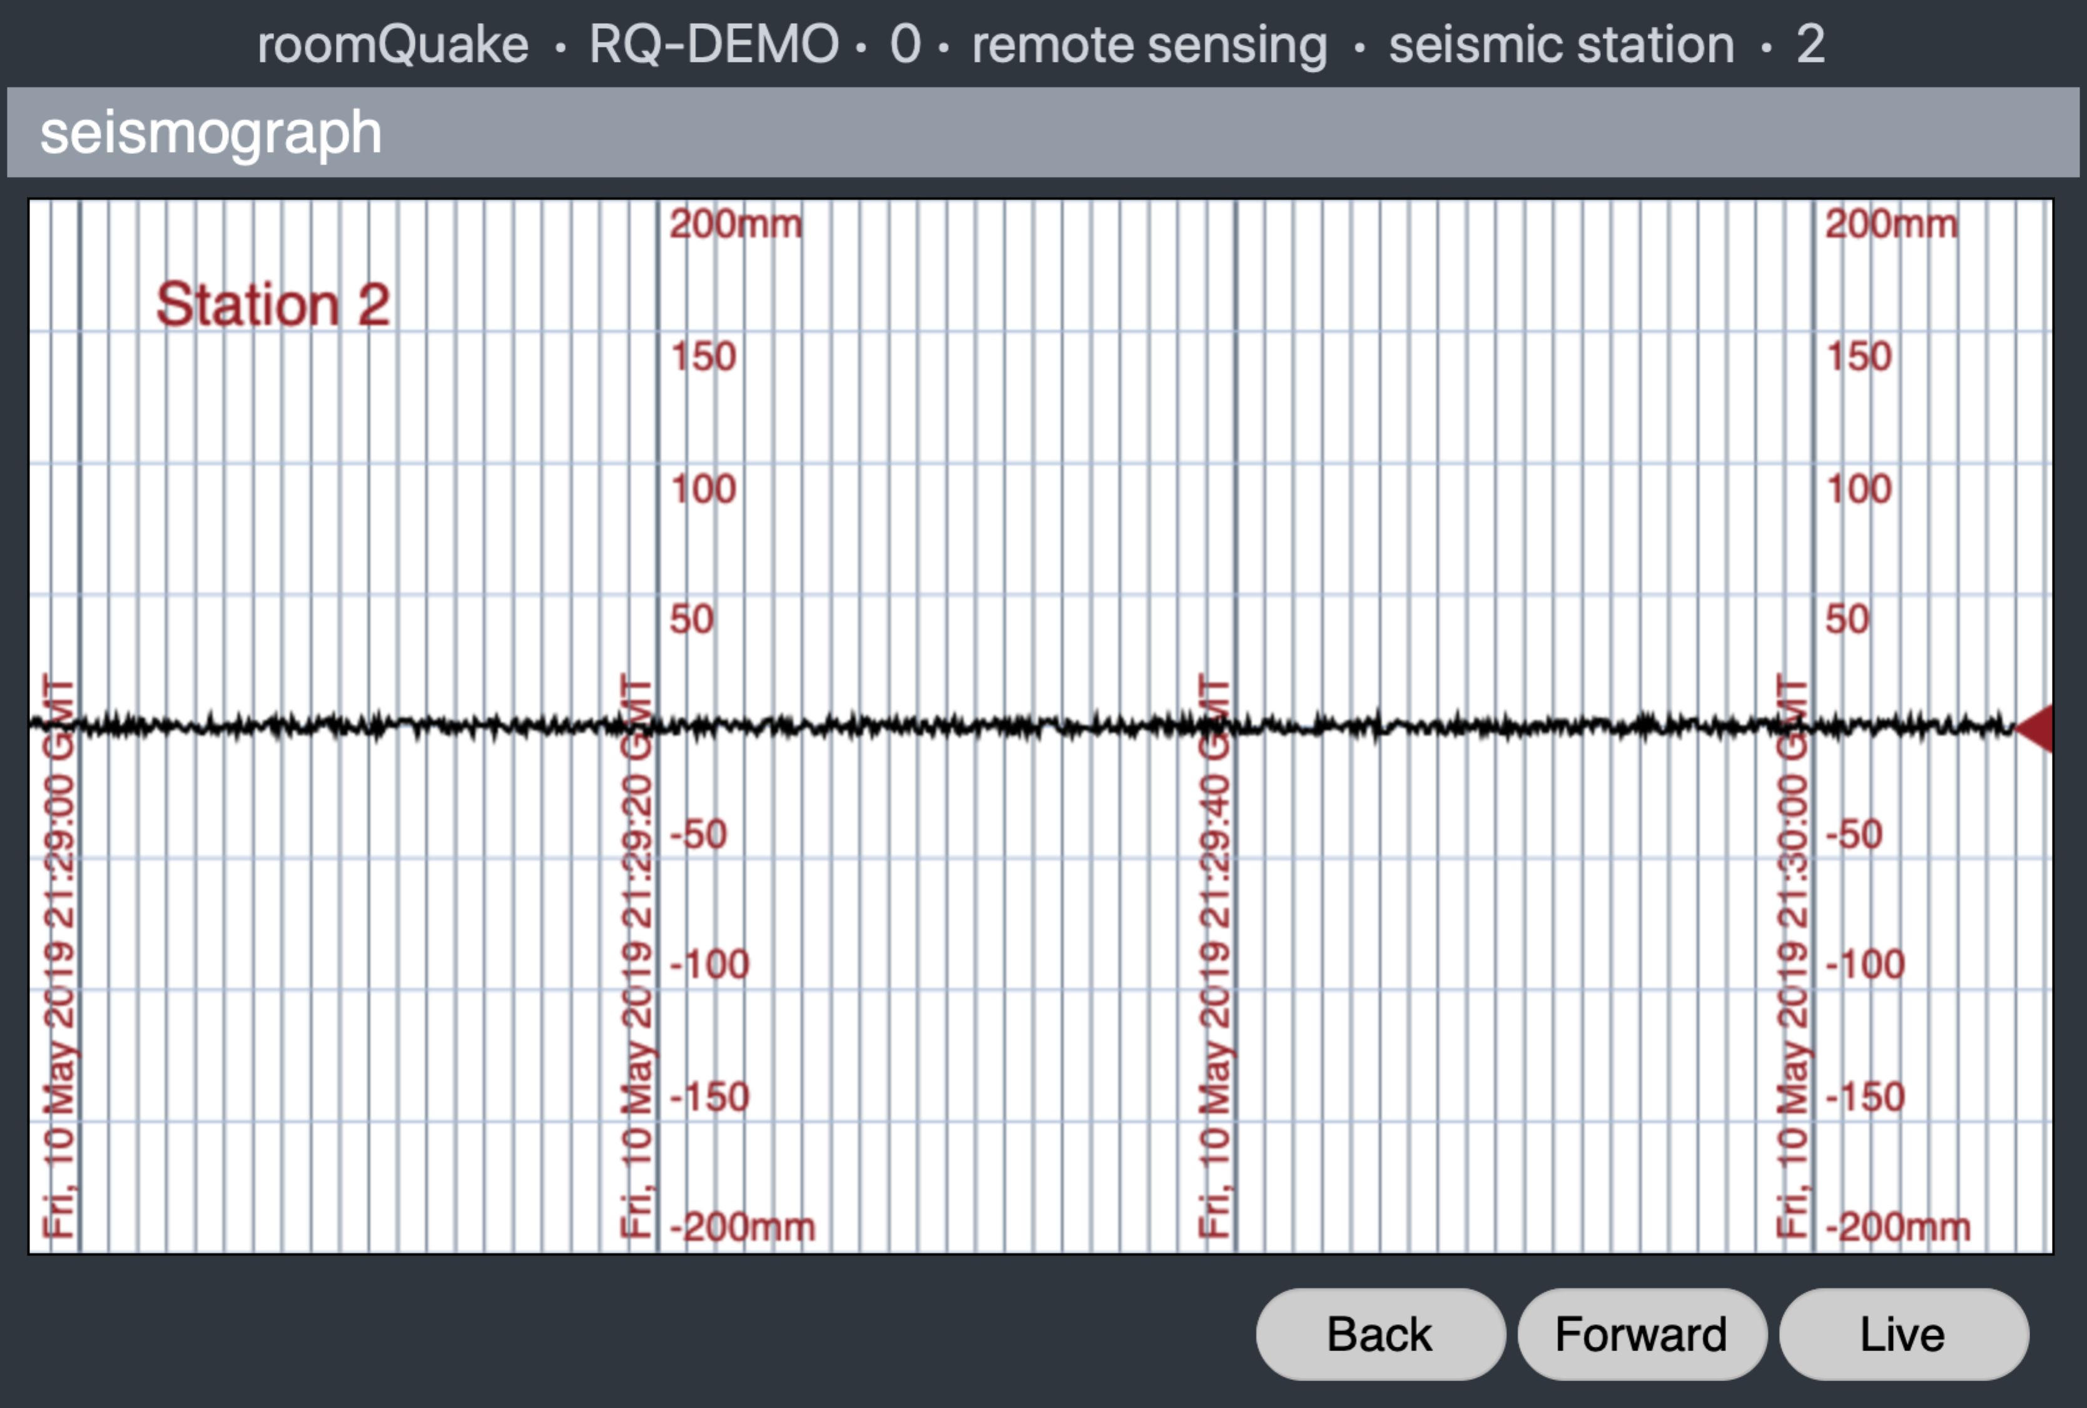

Because the portal was launched during the 'remote sensing' activity, the portal will immediately construct the appropriate resource bar for that activity, based on our distribution plan. (When only one resource is available for an activity, it is automatically displayed in the area beneath the resource bar.)

During enactment, if the web page loses internet connectivity, the user will be presented with the following window. Clicking on the *reconnect* button will send a message to restore connectivity (if possible).

